Codex of Aetherion: A Comprehensive Guide to Understanding the World
The Codex of Aetherion serves as an in-world compendium, compiling lore, mechanics, and entries for travelers, scholars, and seekers navigating the post-Fracture era. It preserves knowledge from pre-System oaths while adapting to new rules of levels, classes, and energies. This guide draws from ancient ruins, guild archives, and codex figures (representative archetypes from each of the 25 species). Structured for clarity, it covers core systems first, then maps, pantheon, magic, species, beasts, and continental overviews—anchoring the narrative of Echoes of Aetherion, where Azrael Raven's journey explores the Betrayer's shadow amid rising powers.
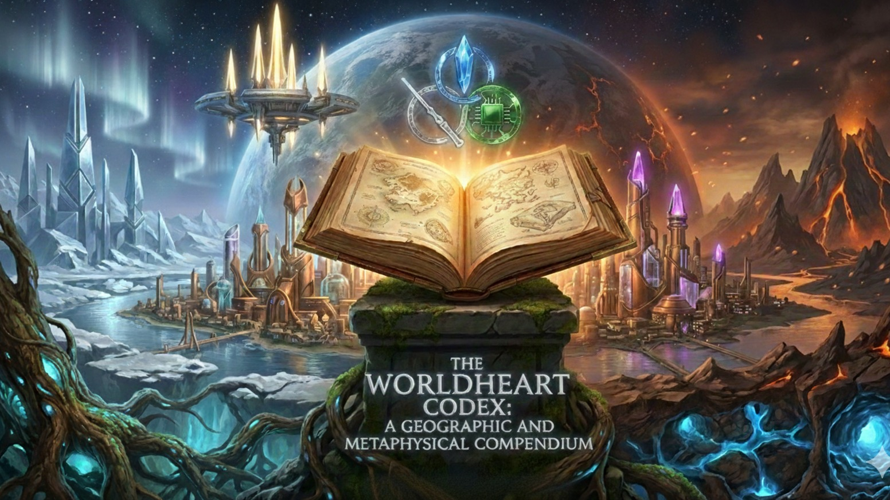
kickstarter.com
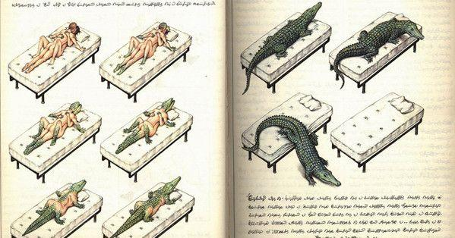
wired.com
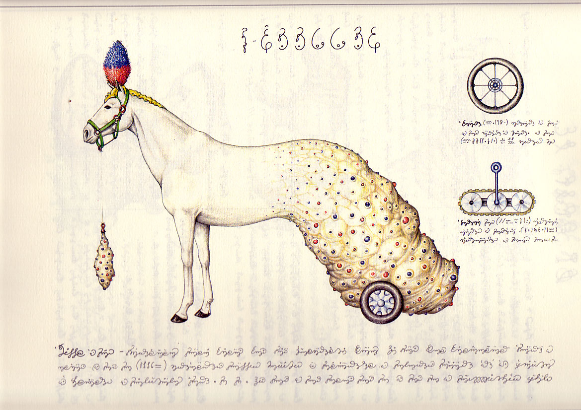
literaturerun.wordpress.com

Core Magic System: Energies, Classes, and Elements
- Core Energies — Kima: Physical life force (strength, endurance). Anima: Spiritual essence (magic, soul). Dual Flow: Harmonious fusion (advanced balance, rare pre-Fracture).
- Classes — Vigor (Kima-focused: warriors, blacksmiths). Arcanus (Anima-focused: mages, summoners). Aequalis (Dual Flow: scouts, mediators).
- Leveling Tiers — Beginner (1-10) → God (2001+, ascended deities).
- 21 Elements — Fire, Water, Wind, Earth, Lightning, Ice, Nature, Metal, Gravity, Light, Shadow, Time, Force, Psychokinesis, Sound, Moon, Necromancy, Demonic, Summoning, Beast Magic, Dark Arts.
- Mechanics → Awakenings via prompts; artifacts/runes amplify; mana veins channel power. The Fracture ended free oaths, imposing System structure—theme of control vs. choice.
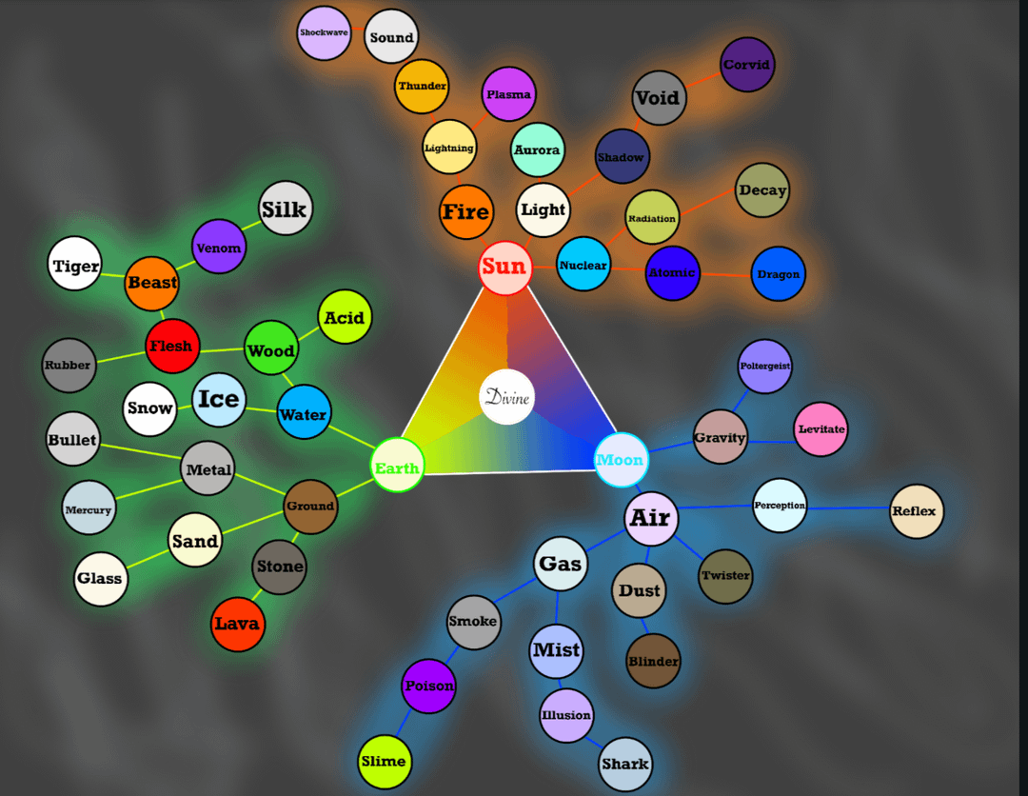
reddit.com
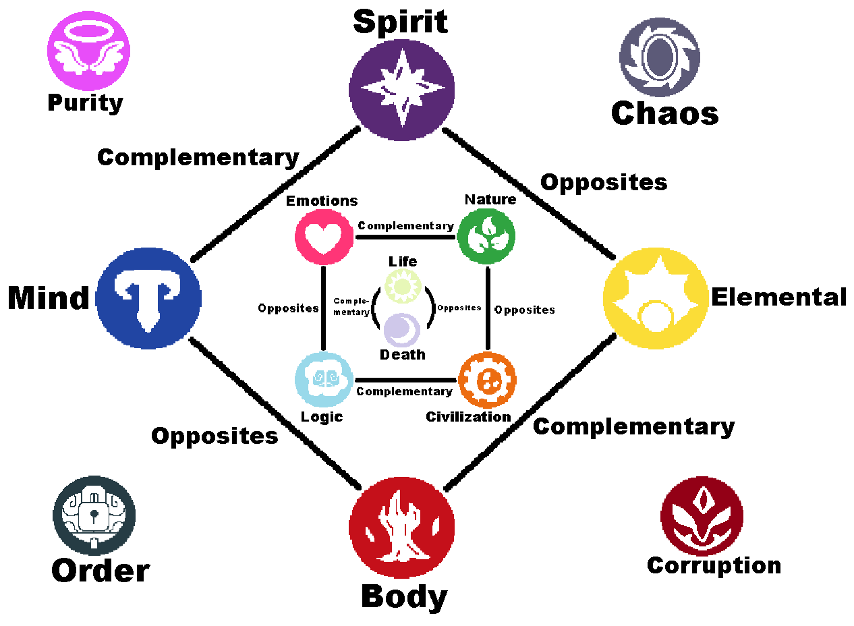
reddit.com
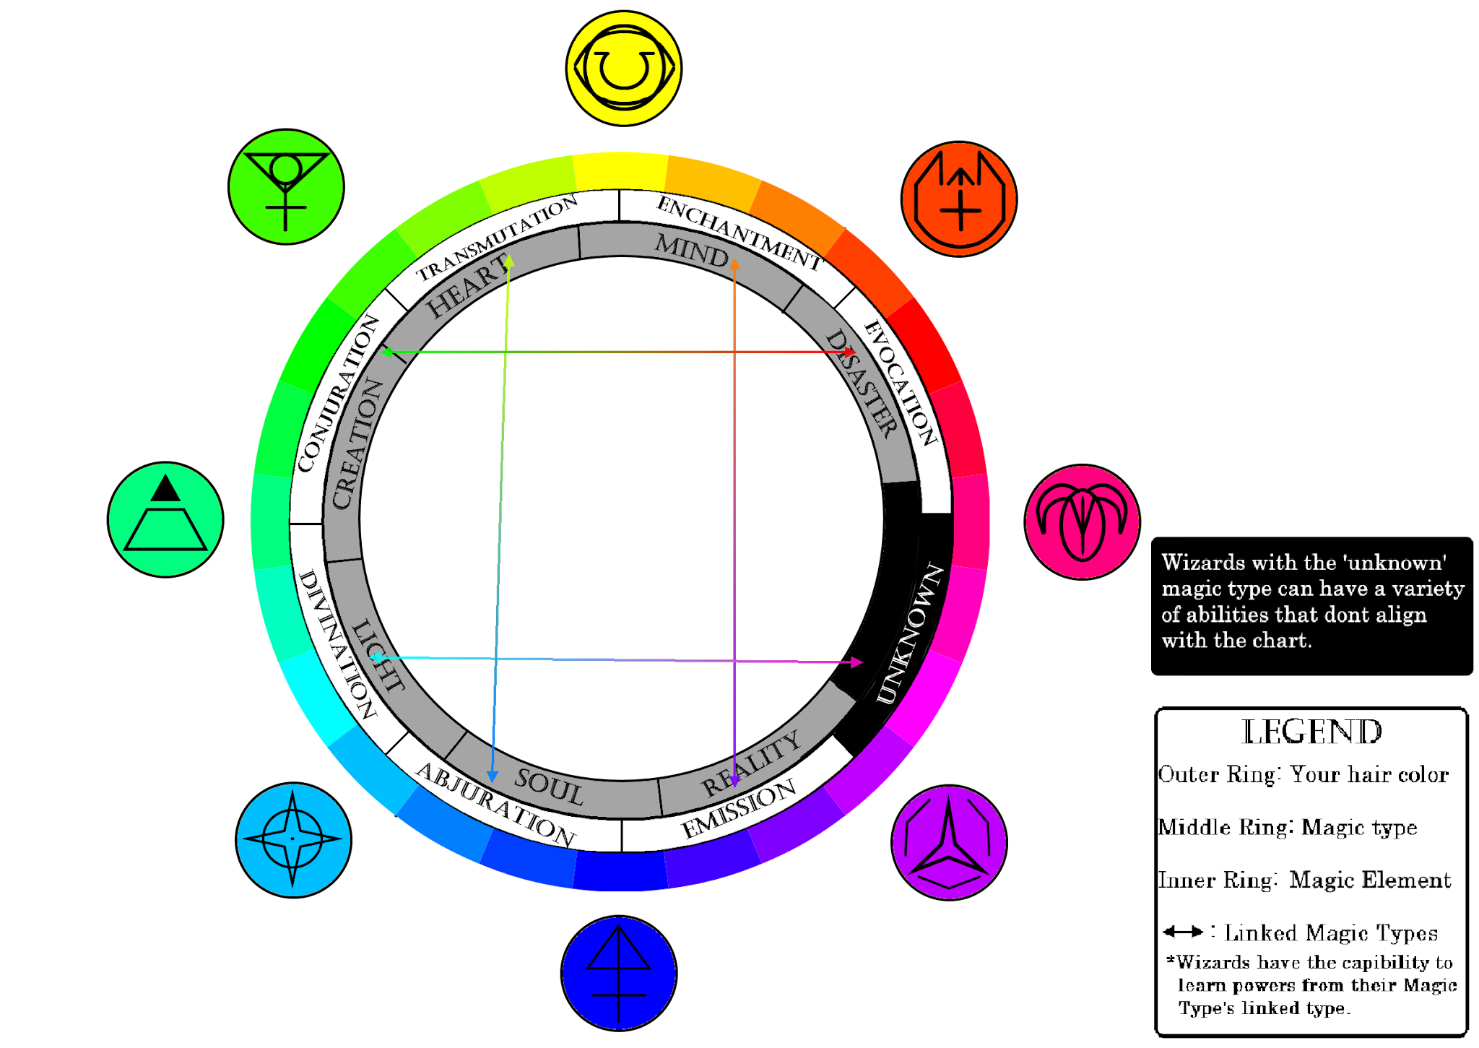
reddit.com

The Pantheon: 18 Gods
Ascended at Level 2001+, these gods shape worship, relics, and conflicts. The hidden Betrayer corrupted rites, causing the Fracture by slaying Aeltharion.
Key examples: Aeltharion (balance, betrayed Sovereign), Aquavelle (tides), Zorathax (forbidden knowledge), Sylvarith (nature veins), Valthorne (forging).
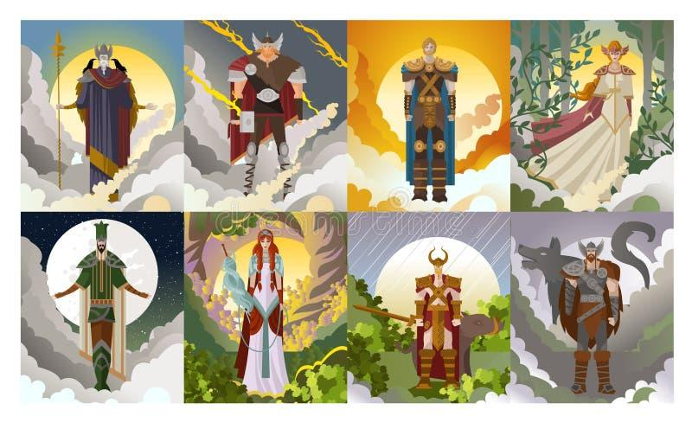
dreamstime.com
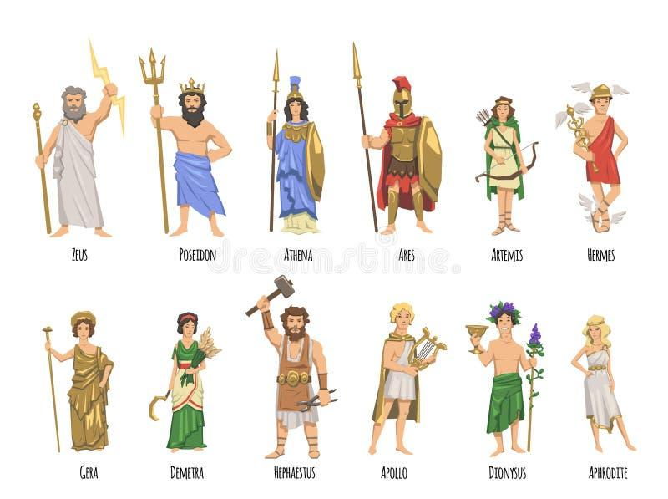
dreamstime.com

Species Codex: 25 Archetypes
Each species has a codex figure (full sheet: Appearance, Favorites, Habits, Personality, Symbolism). Habitats tie to continents; affinities influence magic/culture.
Examples: Humans (adaptable, City of Echoes), Naga (serpentine, jungles), Elves (ethereal, groves), Dwarves (sturdy, forges), Phoenixkin (rebirth, volcanoes), Shadowfolk (elusive, voids).
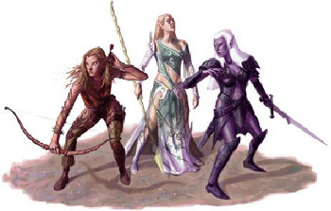
allthetropes.org
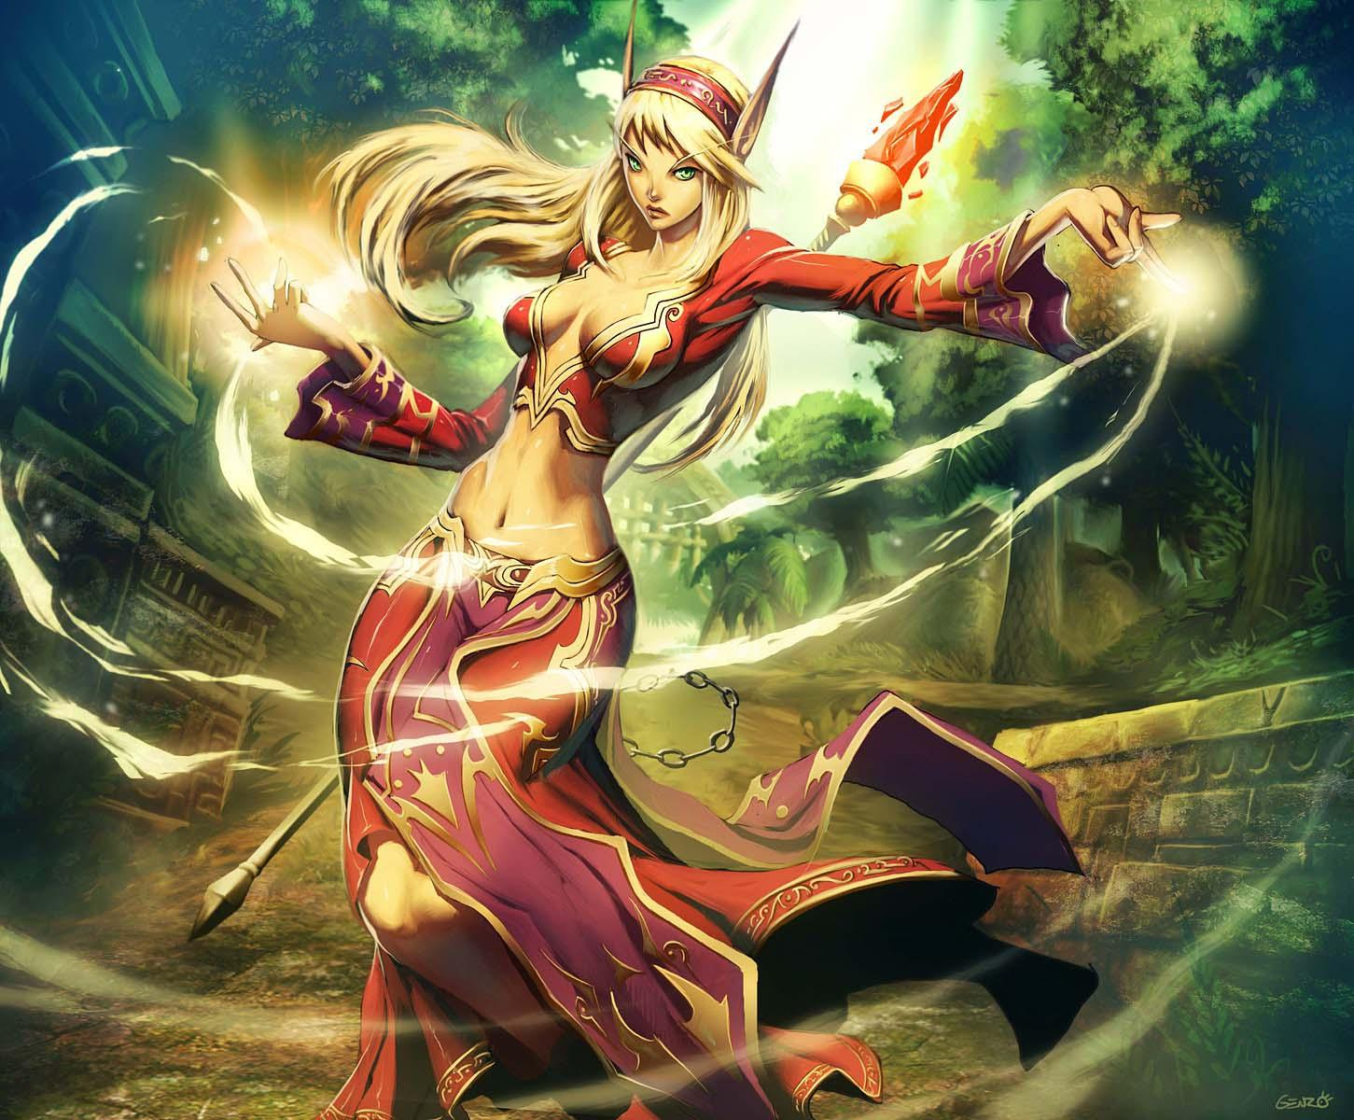
warcraft.wiki.gg
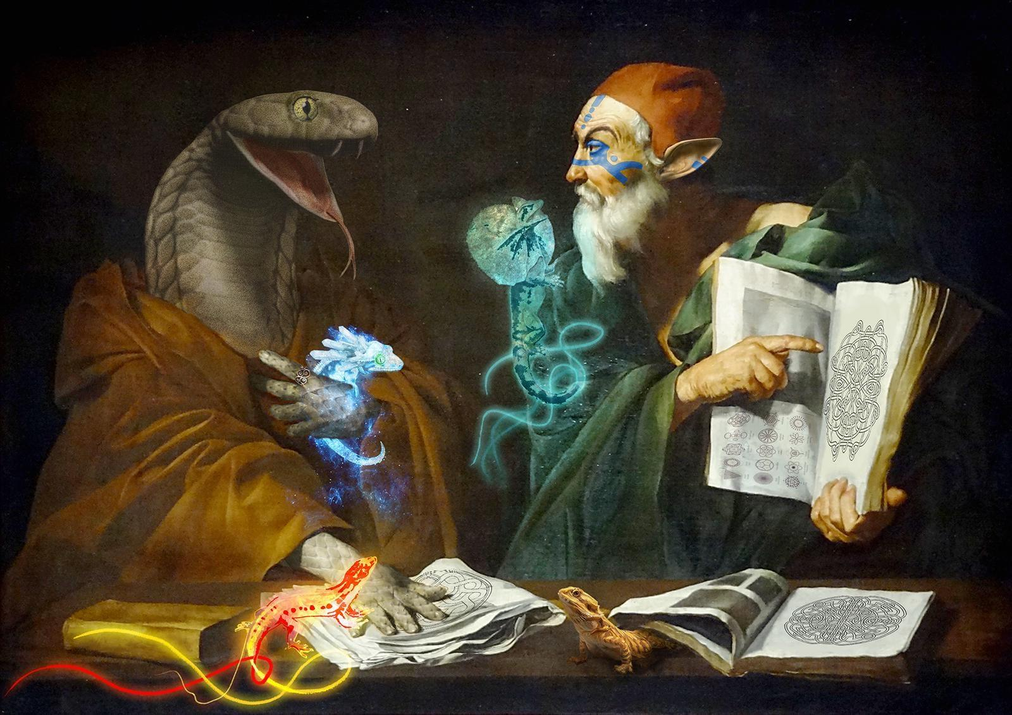
reddit.com

Bestiary: Creatures of Aetherion
50 detailed entries, plus 1,000 procedural variants (20 types × 21 elements × 50+ forms). Beasts spawn in rifts, tied to quests and evolutions.
Examples: Phoenix (rebirth flames), Dragons (elemental lords), Golems (forged guardians), Hydras (regenerating), Krakens (abyssal).
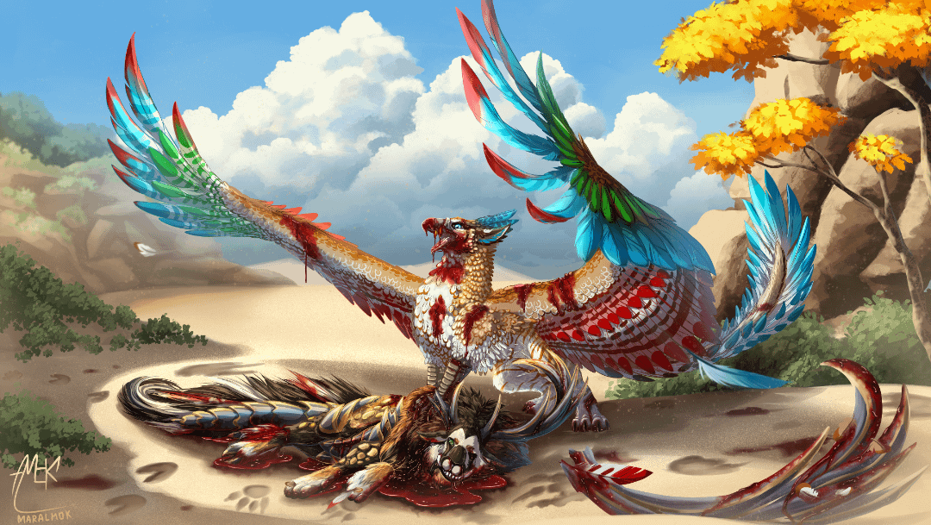
reddit.com
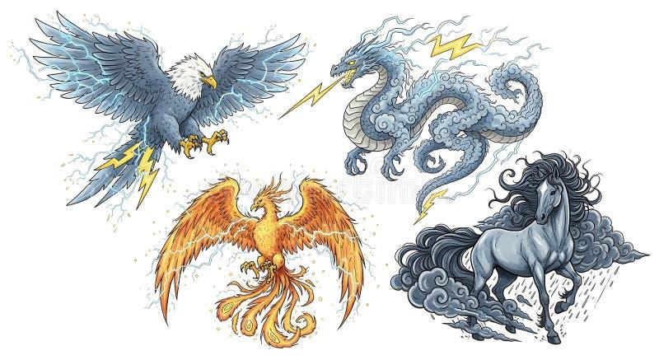
dreamstime.com
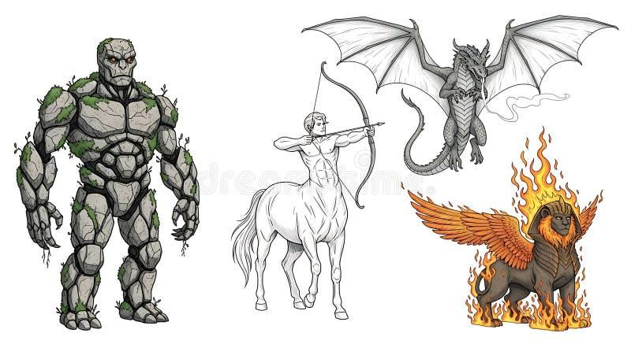
dreamstime.com

World Map and Continents
Seven continents form an archipelago linked by bridges, rivers, and rifts. Elysara centers order; Caelus Prime floats above.
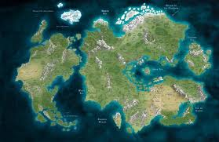
zhaos-immortal-path.fandom.com
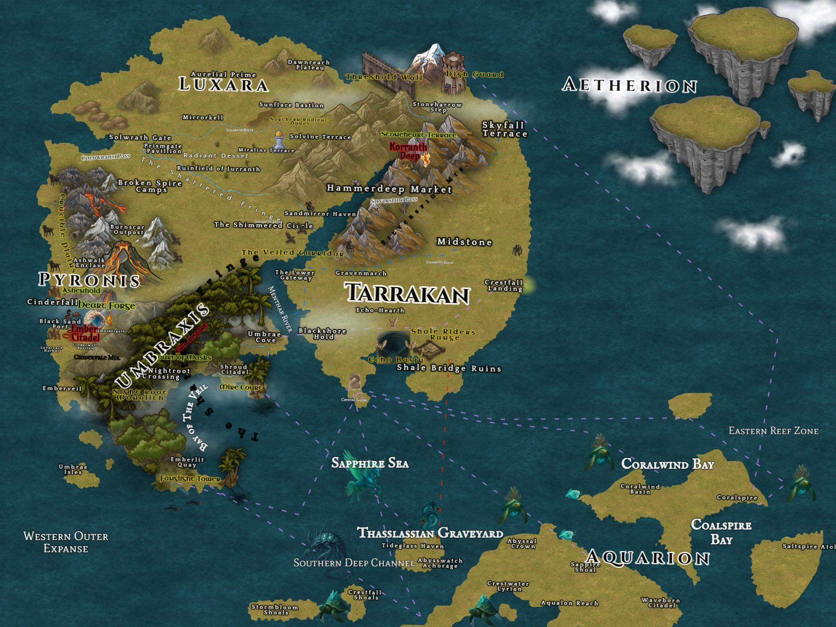
reddit.com
stablediffusionweb.com
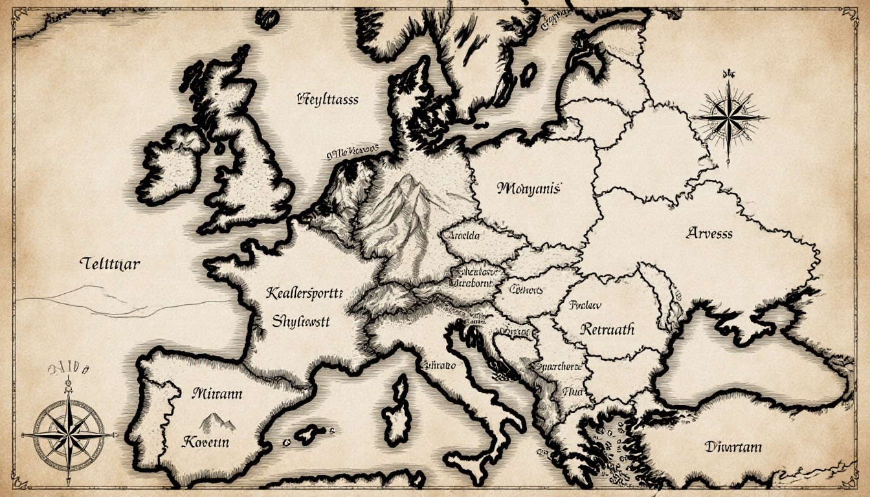
stablediffusionweb.com
This codex illuminates Aetherion's depths, aiding understanding of its histories (Cataclysm War, Fracture), mysteries (Betrayer, Heartgrim's tragedy), and the story's themes—power's cost in a structured world.

The Pantheon of Aetherion: The 18 Gods
In Aetherion, the 18 gods are ascended mortals who reached Level 2001+, wielding godlike mastery over domains tied to the 21 elements and core energies (Kima, Anima, Dual Flow). Once allies under the Celestial Sovereign Aeltharion, their harmony shattered when the hidden Betrayer infiltrated and slew him, triggering the Fracture and birthing the System. Worship varies by continent, with temples, festivals, and relics shaping cultures—yet false Betrayer rites corrupt devotees into madness. Each god has a full character sheet in the codex: Appearance (eternal yet evolving), Favorites, Habits, Personality, Basic Info, and Symbolism/Development tying to the story's themes of power, betrayal, and redemption.
- Aeltharion – God of Balance, Harmony, and Celestial Order
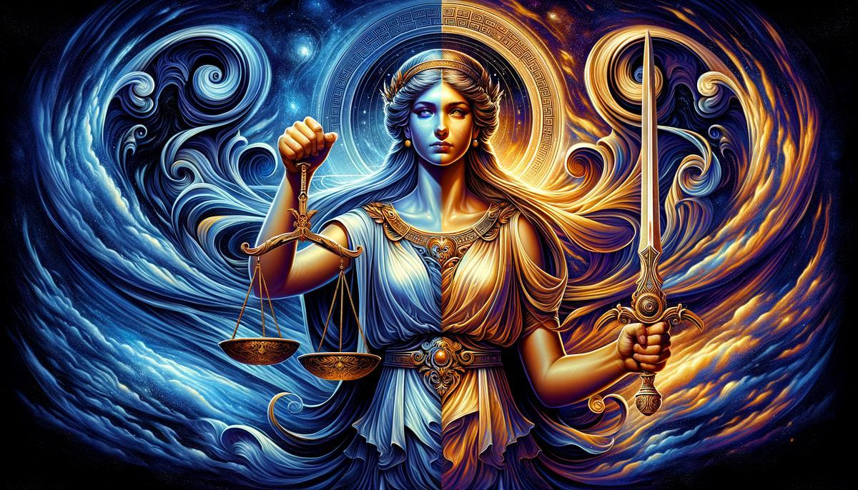
paleothea.com
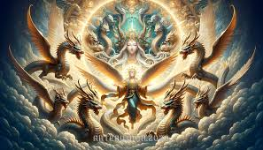
facebook.com
The betrayed Sovereign; his murder anchors the narrative. Domain: Dual Flow mastery, pacts. Worship: Central in Elysara and Caelus Prime. Symbolism: Shattered oaths vs. System chains.
- Aquavelle – Goddess of Tides, Oceans, and Abyssal Change
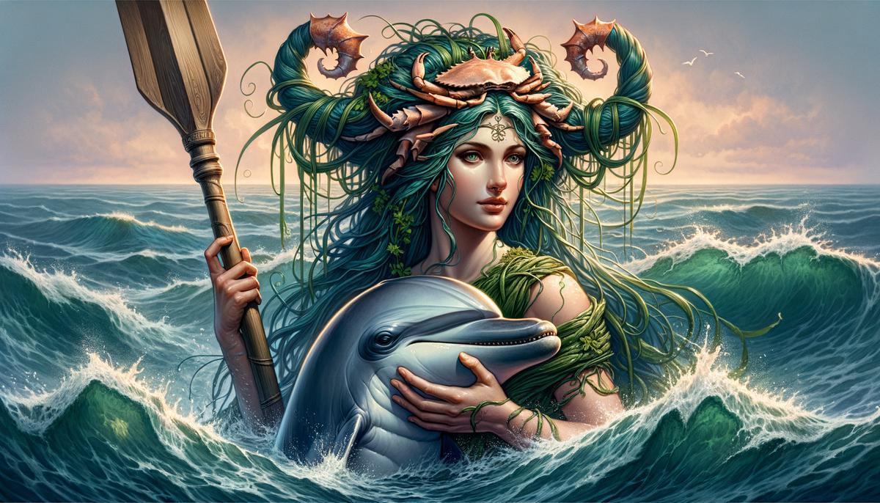
paleothea.com
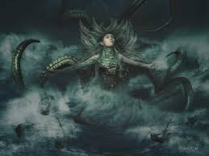
facebook.com
Fluid and unpredictable. Domain: Water, Sound, Lightning. Worship: Dominant in Abyssara.
- Zorathax – God of Forbidden Knowledge, Chaos, and Corruption
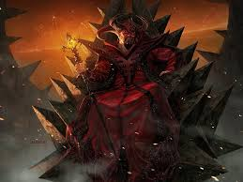
forgottenrealms.fandom.com
litrpgreads.com
Suspected Betrayer link. Domain: Dark Arts, Demonic, Psychokinesis. Worship: Rogue cults across continents.
- Sylvarith – Goddess of Nature, Mana Veins, and Growth
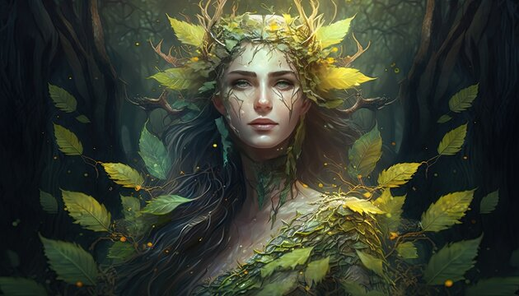
stock.adobe.com
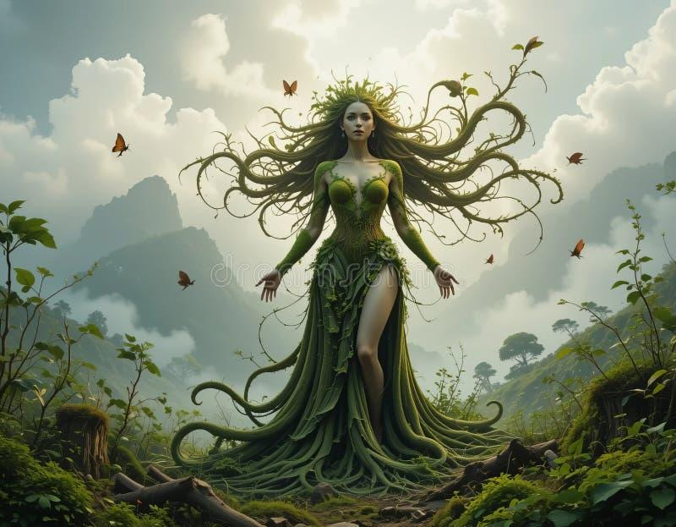
dreamstime.com
Nurturing yet entangled. Domain: Nature, Earth. Worship: Strong in Xihuang and Vindraeth.
- Valthorne – God of Forging, Metal, and Creation
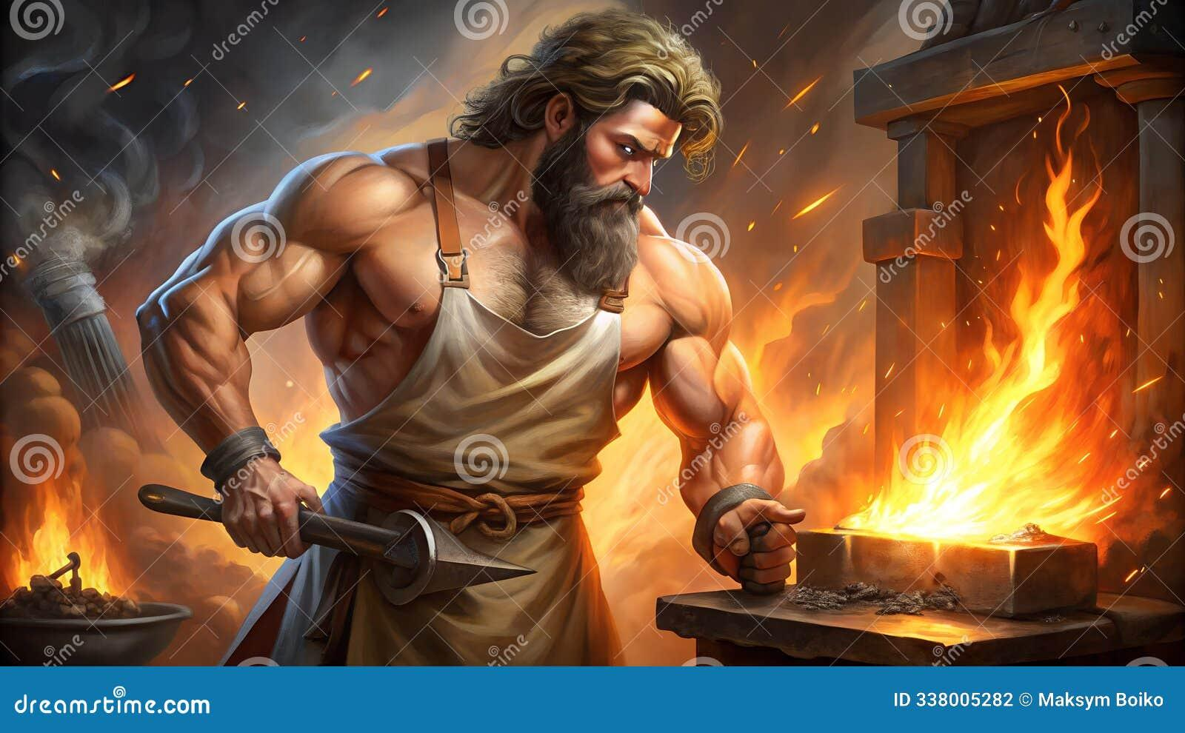
dreamstime.com
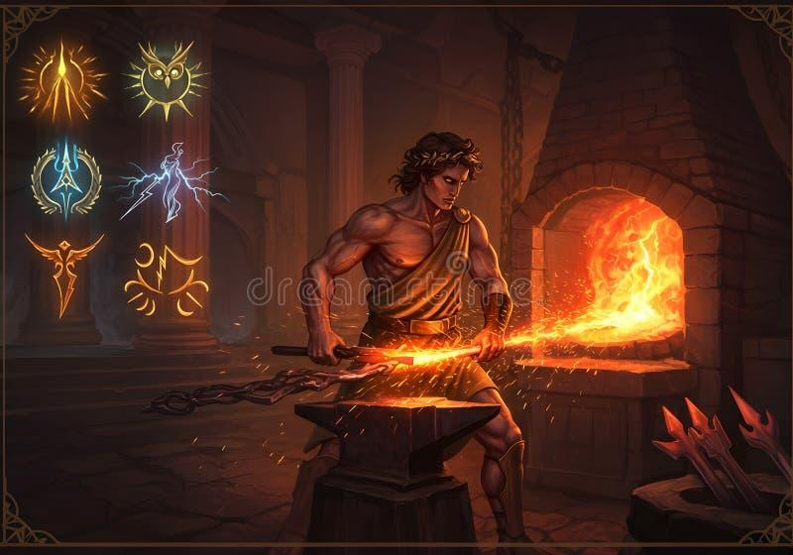
dreamstime.com
Unyielding smith. Domain: Metal, Fire. Worship: Nordheim forges.
- Lumivance – Goddess of Light, Dawn, and Soul Awakening
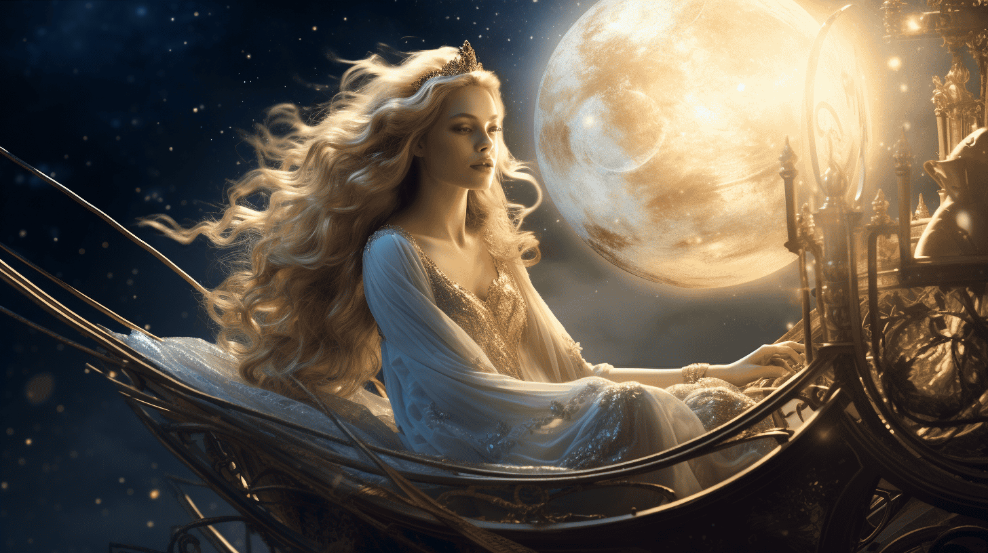
mylifetea.com
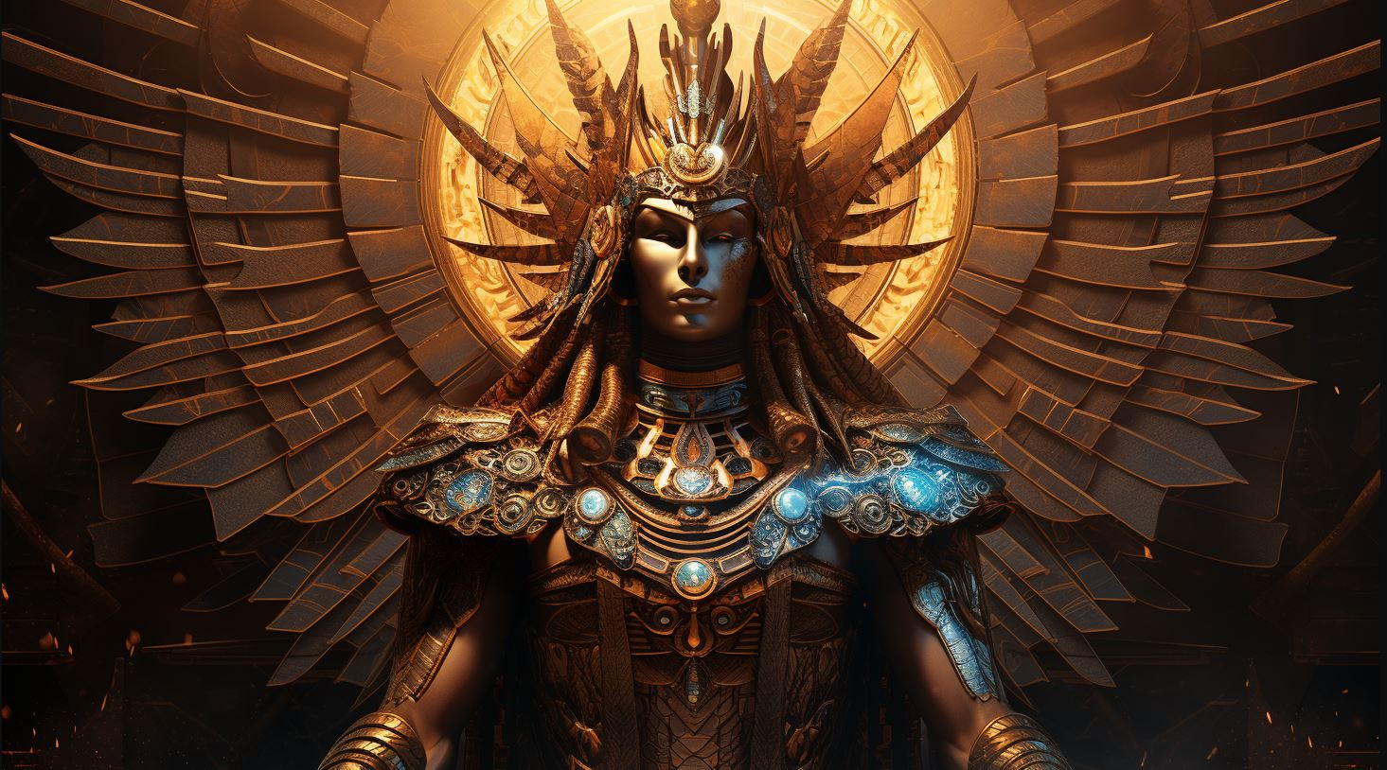
oldworldgods.com
Radiant inspirer. Domain: Light, Force. Worship: Elysara sunspires.
- Chronovael – God of Time, Cycles, and Fate
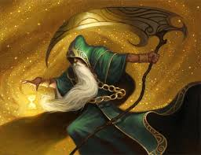
the-stars-in-heaven.fandom.com
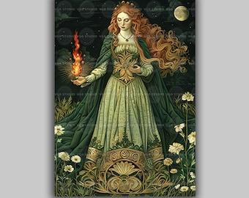
etsy.com
Timeless observer. Domain: Time, Gravity. Worship: Caelus Prime.
- Noctumbra – Goddess of Death, Shadows, and Necromancy
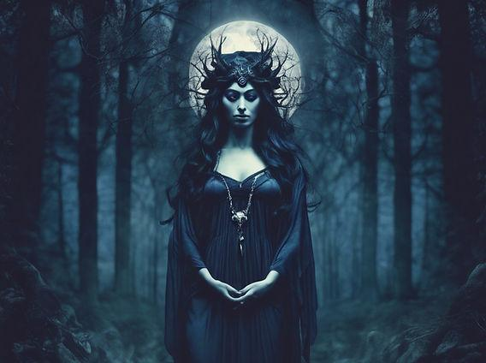
scarletchalice.co.uk
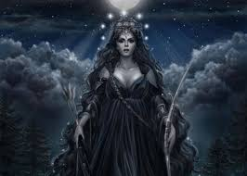
facebook.com
Veiled warden. Domain: Necromancy, Shadow. Worship: Vindraeth voids.
- Feralyth – God of Beasts, Wilderness, and Primal Instinct
mythicalcreaturesandbeasts.com
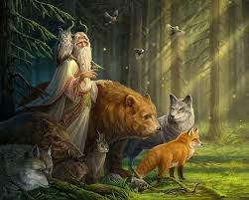
facebook.com
Savage ally. Domain: Beast Magic, Nature. Worship: Tezcal hunts.
- Tenebris – Goddess of Illusions, Dreams, and Moonlit Veils
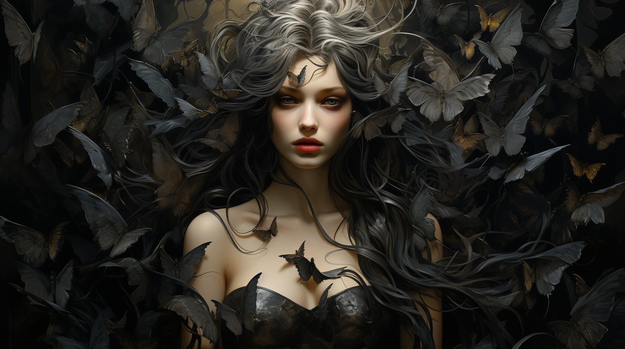
oldworldgods.com
Exploring the Mysteries of Oneiroi in Greek Mythology - Old World Gods
Elusive weaver. Domain: Moon, Psychokinesis. Worship: Abyssara nights.

New Reader Guide to Aetherion
If you’re new to Aetherion, the most important thing to understand is that this is not a world of unlimited growth or effortless power.
Aetherion is a regulated world.
It used to run on belief, oaths, and raw intent. After a catastrophic betrayal known as the Fracture, reality stopped trusting its inhabitants and imposed structure on itself. That structure is called the System.
Most of the story takes place after this change.

What the World Is Like
Aetherion looks like a classic fantasy world on the surface—multiple continents, ancient ruins, different races, magic, monsters—but it doesn’t behave like one.
Magic isn’t free. Power doesn’t grow naturally. Everything passes through rules.
Storms behave strangely. Old locations feel “active.” Some places accelerate growth, others suppress it. The world itself is cautious, almost defensive, because it has already been broken once.
People live normal lives inside that instability.

The System (Without the Jargon)
The System exists to stop reality from collapsing again.
It organizes growth through:
- Levels
- Classes
- Awakening prompts
- Skill restrictions
For most people, the System is helpful. It makes power predictable and survivable. Cities, guilds, and governments rely on it.
For others, especially those who would’ve grown naturally before the Fracture, it feels limiting.
The System isn’t good or evil—it’s control.

Power and Energy
All abilities in Aetherion come from one or more of three energies:
- Kima – Physical power: strength, endurance, reflexes
- Anima – Spiritual power: magic, perception, soul-based abilities
- Dual Flow – A rare balance of both, heavily restricted after the Fracture
Most people naturally lean toward one without ever thinking about it. Labels come later.

Species and People
Aetherion is home to many intelligent species: humans, elves, dwarves, beastkin, naga, abyss-touched races, and more.
Species still influence culture, lifespan, and natural aptitude—but they no longer decide destiny.
Before the Fracture, some races naturally outpaced others. After the System was imposed, those advantages were capped or flattened. A human can surpass an elf. A long-lived race can stagnate.
Adaptability matters more than heritage.

Gods and Myth
The gods of Aetherion are not distant creators. Every god was once mortal.
At extremely high levels, individuals can ascend and gain dominion over elements, concepts, or systems. The current pantheon fractured after one of their own betrayed and killed the Celestial Sovereign, triggering the Fracture.
Gods influence the world, but they are not unified, and they are not infallible.

Continents Matter
Aetherion is divided into seven major continents. Each one affects how power behaves and how people live.
Living in one region long enough can change:
- How fast you grow
- What abilities you develop
- How the System interacts with you
Travel isn’t just geographic—it’s developmental.

What the Story Focuses On
Echoes of Aetherion is not about saving the world overnight.
It’s about:
- Growing up in a world that limits you
- Learning how power actually works
- Understanding the cost of pushing against control
- Deciding what kind of strength is worth pursuing
Azrael Raven’s journey explores these ideas from the ground level up, as the shadow of the Betrayer and the gods slowly re-enter the world.

What to Keep in Mind While Reading
- Power always has a cost
- The System is not the final truth
- Species and status don’t guarantee success
- Old ruins and myths matter more than they seem
- Growth is slow, intentional, and sometimes punished
Aetherion isn’t a world that rewards ambition blindly.
It rewards awareness.

